Program 1: Password Strength Checker
password = input("Enter Password: ")
upper = False
lower = False
digit = False
for ch in password:
if ch.isupper():
upper = True
elif ch.islower():
lower = True
elif ch.isdigit():
digit = True
if len(password) >= 8 and upper and lower and digit:
print("Password is Strong.")
else:
print("Password is Weak.")
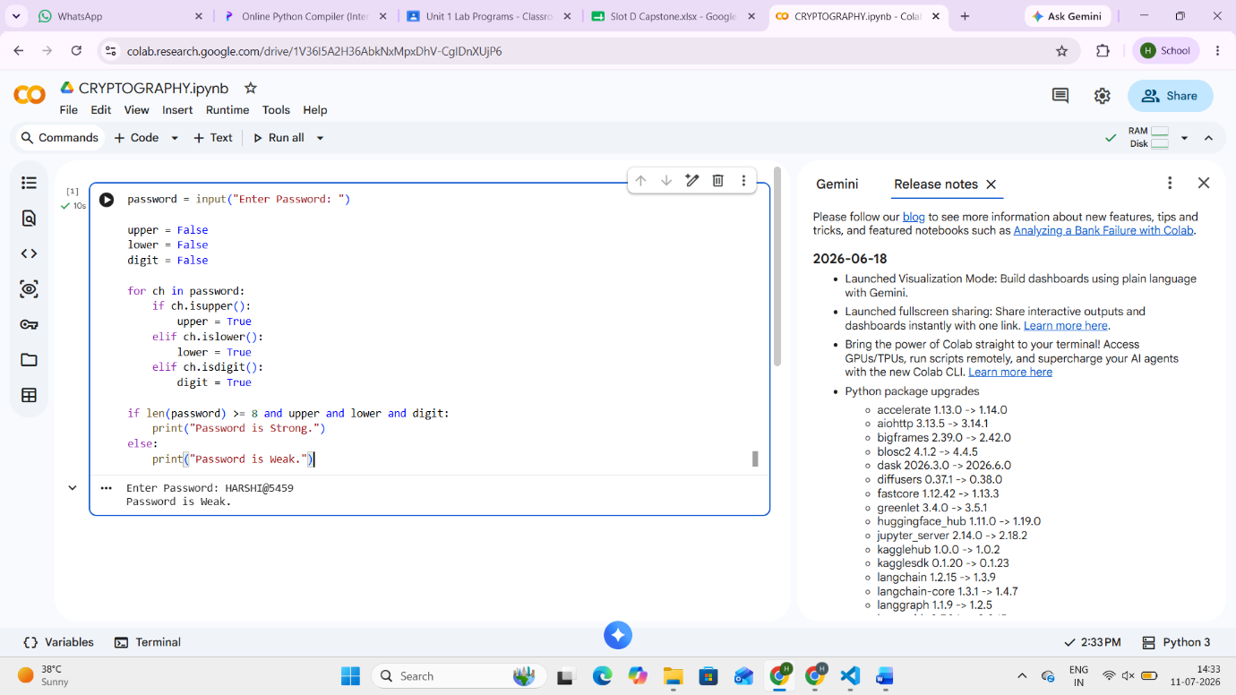
OUTPUT:

Program 2: Login Authentication
username = "admin"
password = "admin123"
u = input("Username: ")
p = input("Password: ")
if u == username and p == password:
print("Login Successful")
else:
print("Invalid Username or Password")
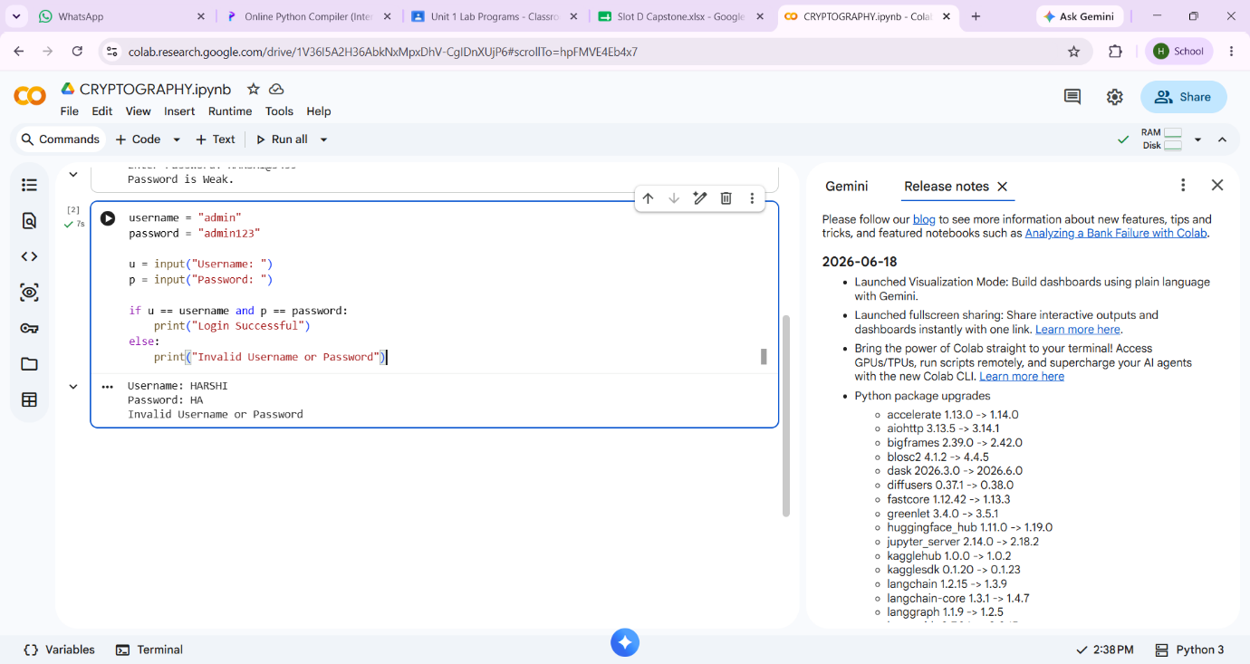
Program 3: File Access Permission Simulation
role = input("Enter Role: ")
if role.lower() == "admin":
print("Permissions:")
print("Read")
print("Write")
print("Delete")
elif role.lower() == "faculty":
print("Permissions:")
print("Read")
print("Write")
elif role.lower() == "student":
print("Permissions:")
print("Read Only")
else:
print("Invalid Role")
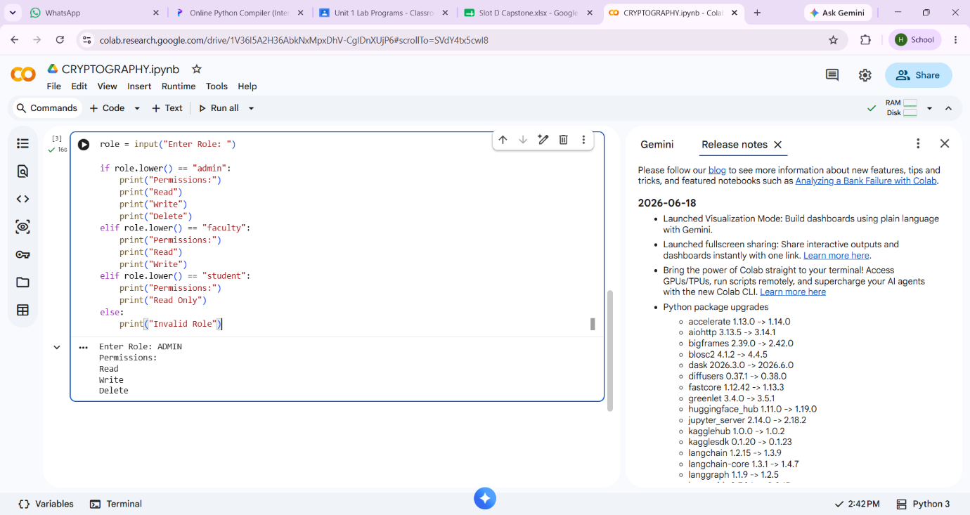
Program 4: Bell–LaPadula Access Checker
levels = {
"public": 1,
"confidential": 2,
"secret": 3,
"top secret": 4
}
user = input("User Level: ").lower()
file = input("File Level: ").lower()
operation = input("Operation (Read/Write): ").lower()
if operation == "read":
if levels[user] >= levels[file]:
print("Access Allowed")
else:
print("Access Denied")
print("Reason: No Read Up")
elif operation == "write":
if levels[user] <= levels[file]:
print("Access Allowed")
else:
print("Access Denied")
print("Reason: No Write Down")
else:
print("Invalid Operation")
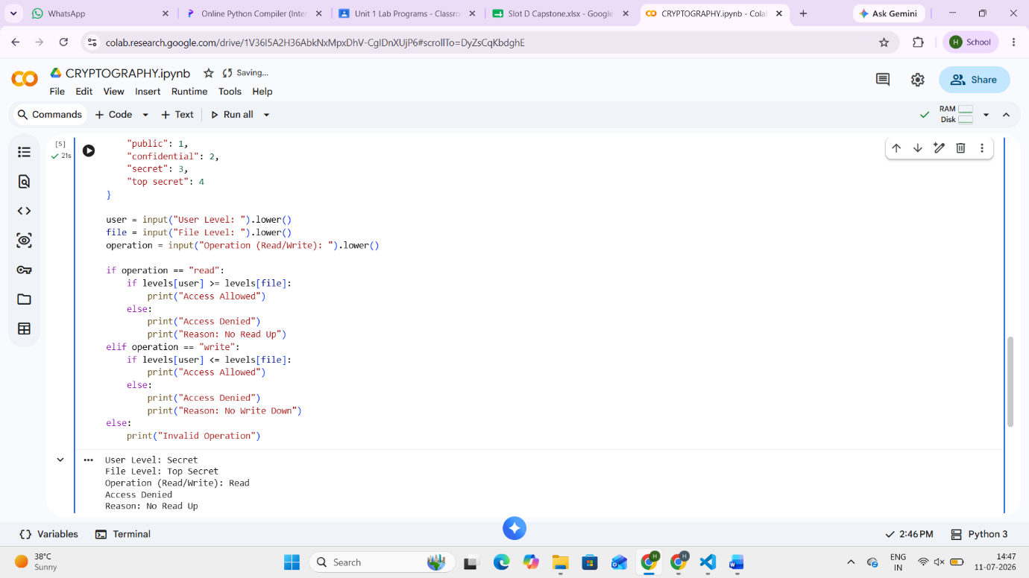
Program 5: Security Risk Level Calculator
likelihood = int(input("Likelihood (1-5): "))
impact = int(input("Impact (1-5): "))
risk = likelihood * impact
print("Risk Score:", risk)
if risk <= 5:
print("Risk Level: Low")
elif risk <= 15:
print("Risk Level: Medium")
else:
print("Risk Level: High")
